CHAPTER 1
DATA BASE SYSTEMS

DATA: Data is a collection of raw facts. Data constitute the building blocks of Information. For example, roll no, sname, group, address, phone no, etc., are data items.
INFORMATION: Information is the result of processed data to reveal its meaning. Timely and useful information requires accurate data.
For example, in a student database file having the information of (1, Srinivas, CSE, Tadepalligudem). It is the information of particular student having a group of data items.
DATABASE: It is a collection of interrelated data that contains information about one particular organization or enterprise. It consists of collection database files.
SYMBOL of database:

DBMS: A database management system (DBMS) is a collection of programs that manages the database structure and controls access to the data stored in the database. It is a software layer.
Basic File Terminology Definitions:
Field: A character or group of characters that has a specific meaning. A field is used to define and store data. For example in a EMP file eno,ename,sal etc are fields.

Record: A logical collection of one or more fields that describes a person, place or thing. For Example the fields that constitute a record for employee named Rama might consists of Rama’s name,Idno,sal etc.,

File: File is a collection of related records. For example a PRODUCT file contains all records of product file.
Ex: The records of STUDENT file are given below
Student No. | SName | Marks1 | Marks2 | Marks3
S01 | Saritha | 80 | 60 | 70
S02 | Kavitha | 70 | 80 | 60
S03 | Krishna | 60 | 70 | 90

File System versus DBMS:
Basis | File System | DBMS
Structure | The file system is a way of arranging the files in a storage medium within a computer. | DBMS is software for managing the database.
Data Redundancy | Redundant data can be present in a file system. | In DBMS there is no redundant data.
Backup and Recovery | It doesn’t provide backup and recovery of data if it is lost. | It provides backup and recovery of data even if it is lost.
Query processing | There is no efficient query processing in the file system. | Efficient query processing exist in DBMS.
Consistency | There is less data consistency in the file system. | There is more data consistency because of the process of normalization.
Complexity | It is less complex as compared to DBMS. | It has more complexity in handling as compared to the file system.
Security Constraints | File systems provide less security in comparison to DBMS. | DBMS has more security mechanisms as compared to file systems.
Cost | It is less expensive than DBMS. | It has a comparatively higher cost than a file system.
Data Independence | There is no data independence. | In DBMS data independence exists.
User Access | Only one user can access data at a time. | Multiple users can access data at a time.
Sharing | Data is distributed in many files. So, not easy to share data | Due to centralized nature sharing is easy
Data Abstraction | It give details of storage and representation of data | It hides the internal details of Database
Integrity Constraints | Integrity Constraints are difficult to implement | Integrity constraints are easy to implement
Example | Cobol, C++ | Oracle, SQL Server

Role of DBMS , Advantages & Disadvantages
Role of DBMS: The DBMS serves as the intermediary between the user and the database. The database structure itself is stored as a collection of files, and the only way to access the data in those files is through the DBMS.
Advantages of DBMS: Having a DBMS between the end user’s applications and the database offers some important advantages. They are:
- Improved data sharing
- Improved data security
- Better data integration
- Minimized data inconsistency
- Improved data access
- Improved decision making
- Increased end-user productivity.
- Improved data sharing: The DBMS helps create an environment in which end users have better access to more data and better managed data. Such type of data sharing helps the end users to respond quickly to changes in their environment.
- Improved data security: The more users access the data, the greater the risk of data security. A DBMS provides a framework for better enforcement of data privacy and security policies.
- Better data integration: Wider access to well managed data promotes an integrated view of the organization’s operations. It becomes much easier to see how action in one segment of the company affect other segments.
- Minimized data inconsistency: Data inconsistency exists when different versions of the same data appear in different places. The probability of data inconsistency is greatly reduced in a properly designed database.
- Improved data access: The DBMS makes it possible to produce quick answer to Ad hoc queries. In a database ,a query is a specific request issued to the DBMS for data manipulations and retrieval . The DBMS sends output of query (result set) to the application.
- Improved decision making: Better managed data and improved data access make it possible to generate better quality information ,on which better decisions are taken.
- Increased end-user productivity: The availability of data combined with the tools that transform data into usable information, helps end users to make quick decisions.

Data Model : Data models describe how a database's logical structure is represented. In a database management system, data models are essential for introducing abstraction. Data models specify how data is linked to one another, as well as how it is handled and stored within the system.
Types of Data Models in DBMS
- Hierarchical Model. This concept uses a hierarchical tree structure to organize the data.
- Network Model.
- Entity-Relationship Model.
- Relational Model.
- Object-Oriented Data Model.
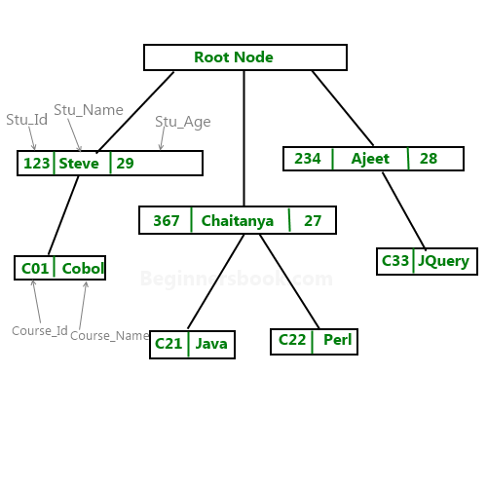
Hierarchical Model : The hierarchical Model is one of the oldest data model which was developed by IBM, in the 1950s. In a hierarchical model, data are viewed as a collection of segments that form a hierarchical relation. In this, the data is organized into a tree-like structure where each record consists of one parent record and many children. Even if the segments are connected as a chain-like structure by logical associations, then the instant structure can be a fan structure with multiple branches.

Network Data Model This model was formalized by the Database Task group in the 1960s. This model is the generalization of the hierarchical model. This model can consist of multiple parent segments and these segments are grouped as levels but there exists a logical association between the segments belonging to any level. Mostly, there exists a many-to-many logical association between any of the two segments. We called graphs the logical associations between the segments. There will be more connections among different nodes. It can have M: N relations i.e, many-to-many which allows a record to have more than one parent segment.
Here, a relationship is called a set, and each set is made up of at least 2 types of record which are given below:
- An owner record that is the same as of parent in the hierarchical model.
- A member record that is the same as of child in the hierarchical model.

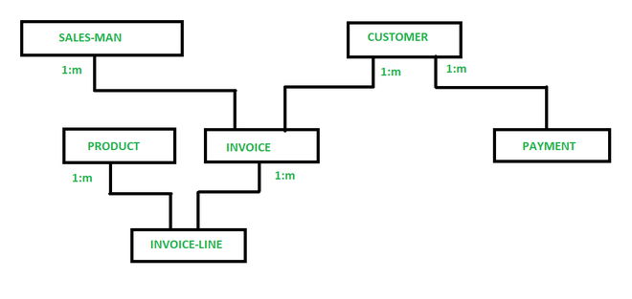

Entity – Relationship Model : Entity-Relationship (ER) Model is based on the notion of real-world entities and relationships among them. While formulating real-world scenario into the database model, the ER Model creates entity set, relationship set, general attributes and constraints.
ER Model is best used for the conceptual design of a database.
ER Model is based on −
- Entities and their attributes.
- Relationships among entities.
These concepts are explained below.
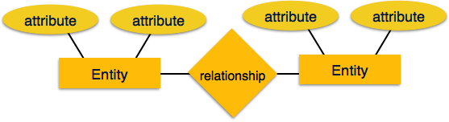
- Entity − An entity is a thing, place, or person in the real-world having properties called attributes. Every attribute is defined by its set of values called domain. For example, in a school database, a student is considered as an entity. Student has various attributes like name, age, class, etc.
- Relationship − The logical association among entities is called relationship. Relationships are mapped with entities in various ways. Mapping cardinalities define the number of association between two entities. Mapping cardinalities are one to one, one to many, many to one and many to many.
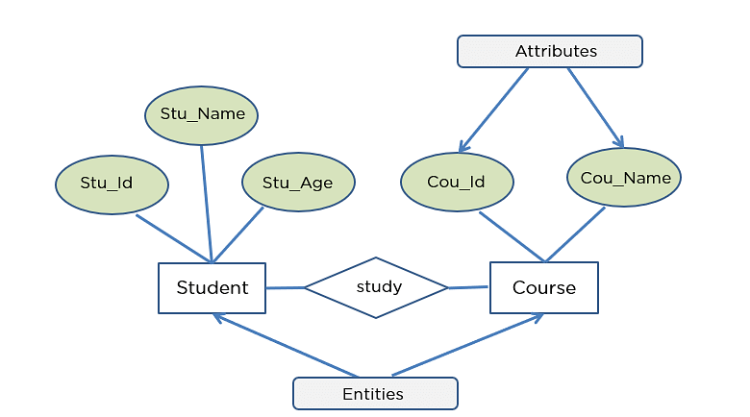

Relational Data Model : The relational model for database management is an approach to logically represent and manage the data stored in a database. In this model, the data is organized into a collection of two-dimensional inter-related tables, also known as relations. Each relation is a collection of columns and rows, where the column represents the attributes of an entity and the rows (or tuples) represents the records.

Properties of Relations :
- Name of the relation is distinct from all other relations.
- Each relation cell contains exactly one atomic (single) value
- Each attribute contains a distinct name
- Attribute domain has no significance
- Tuple has no duplicate value
- Order of tuple can have a different sequence
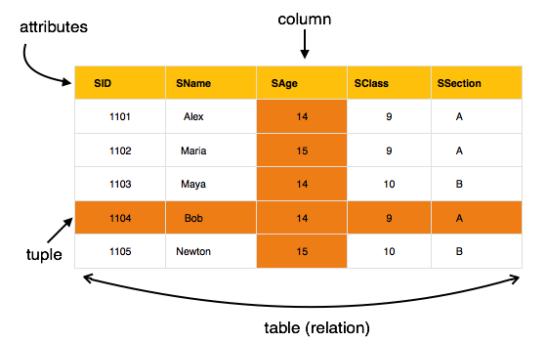
Object Oriented Data Model : The OODM is a better representation of real-world challenges. Both the data and the relationship are contained into a single structure that’s known as an object in this model. We can now store audios, pictures, videos, and other types of data in databases, which was previously impossible with the relational approach (Although you can store video and audio in relational DB, it is generally advised not to store them in the relational DB).
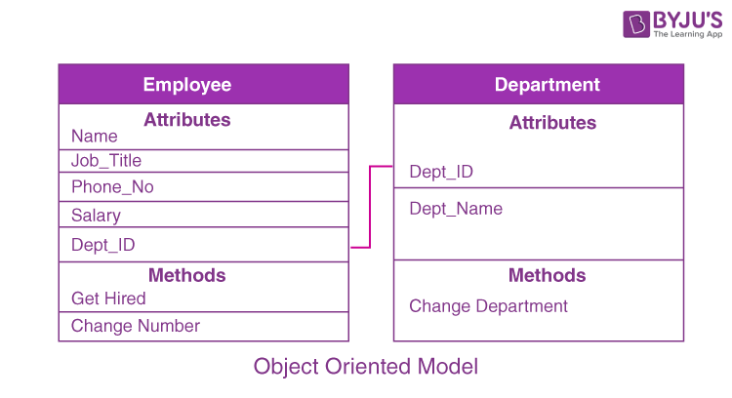
Data Abstraction is a process of hiding unwanted or irrelevant details from the end user. It provides a different view and helps in achieving data independence which is used to enhance the security of data.
The database systems consist of complicated data structures and relations. For users to access the data easily, these complications are kept hidden, and only the relevant part of the database is made accessible to the users through data abstraction.

Levels of abstraction for DBMS
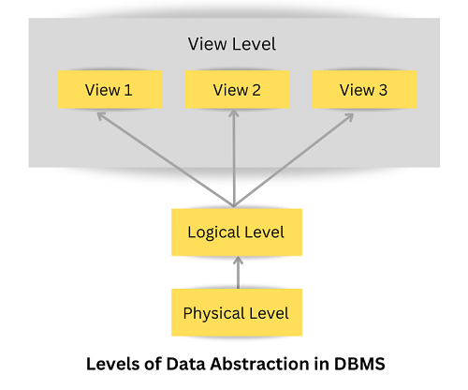
Database systems include complex data-structures. In terms of retrieval of data, reduce complexity in terms of usability of users and in order to make the system efficient, developers use levels of abstraction that hide irrelevant details from the users. Levels of abstraction simplify database design.
Mainly there are three levels of abstraction for DBMS, which are as follows −
- Physical or Internal Level
- Logical or Conceptual Level
- View or External Level
These levels are shown in the diagram below −

Let us discuss each level in detail.

Physical or Internal Level : It is the lowest level of abstraction for DBMS which defines how the data is actually stored, it defines data-structures to store data and access methods used by the database. Actually, it is decided by developers or database application programmers how to store the data in the database.
So, overall, the entire database is described in this level that is physical or internal level. It is a very complex level to understand. For example, customer's information is stored in tables and data is stored in the form of blocks of storage such as bytes, gigabytes etc.

Logical or Conceptual Level: Logical level is the intermediate level or next higher level. It describes what data is stored in the database and what relationship exists among those data. It tries to describe the entire or whole data because it describes what tables to be created and what are the links among those tables that are created.
It is less complex than the physical level. Logical level is used by developers or database administrators (DBA). So, overall, the logical level contains tables (fields and attributes) and relationships among table attributes.

View or External Level : It is the highest level. In view level, there are different levels of views and every view only defines a part of the entire data. It also simplifies interaction with the user and it provides many views or multiple views of the same database.
View level can be used by all users (all levels' users). This level is the least complex and easy to understand.
For example, a user can interact with a system using GUI that is view level and can enter details at GUI or screen and the user does not know how data is stored and what data is stored, this detail is hidden from the user.
Structure of DBMS : Database Management System (DBMS) is software that allows access to data stored in a database and provides an easy and effective method of –
- Defining the information.
- Storing the information.
- Manipulating the information.
- Protecting the information from system crashes or data theft.
- Differentiating access permissions for different users.

Three Parts that make up the Database System are:
- Query Processor
- Storage Manager
- Disk Storage

1. Query Processor : The query processing is handled by the query processor, as the name implies. It executes the user's query, to put it simply. In this way, the query processor aids the database system in making data access simple and easy. The query processor's primary duty is to successfully execute the query. The Query Processor transforms (or interprets) the user's application program-provided requests into instructions that a computer can understand.

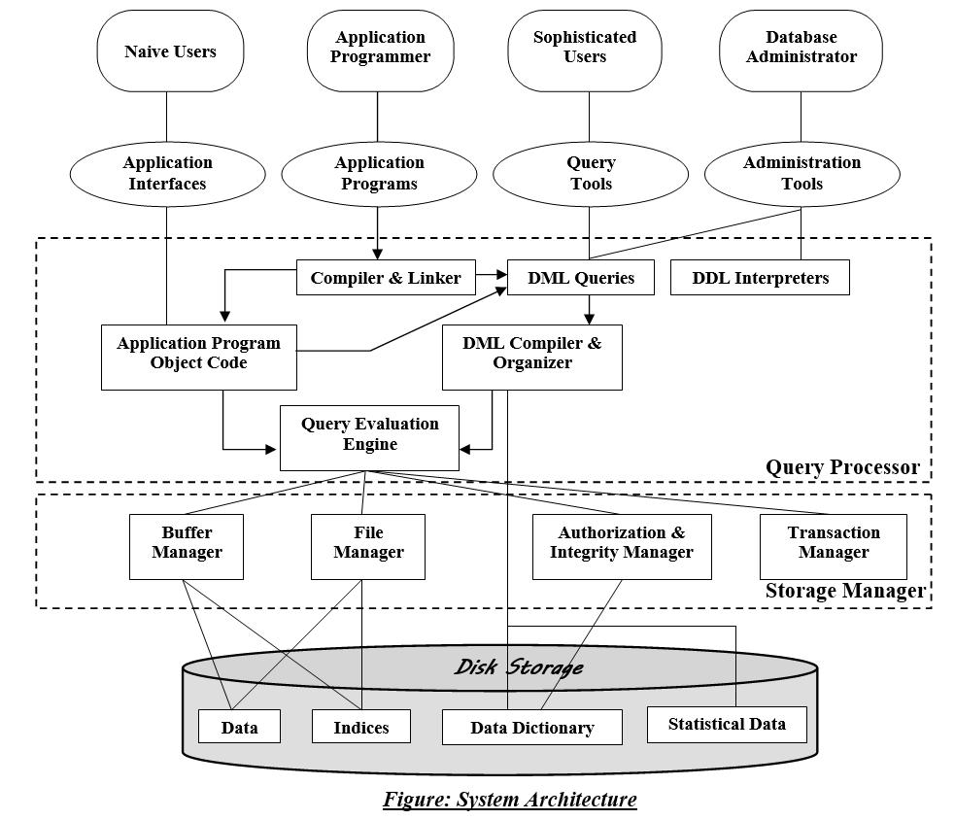

Components of the Query Processor:
- DDL Interpreter:
Data Definition Language is what DDL stands for. As implied by the name, the DDL Interpreter interprets DDL statements like those used in schema definitions (such as create, drop, etc.). This interpretation yields a set of tables that include the meta-data (data of data) that is kept in the data dictionary. Metadata may be stored in a data dictionary. In essence, it is a part of the disc storage.
- DML Compiler:
Compiler for DML Data Manipulation Language is what DML stands for. In keeping with its name, the DML Compiler converts DML statements like select, update, and delete into low-level instructions or simply machine-readable object code, to enable execution. The optimization of queries is another function of the DML compiler. Since a single question can typically be translated into a number of evaluation plans. As a result, some optimization is needed to select the evaluation plan with the lowest cost out of all the options. This process, known as query optimization, is exclusively carried out by the DML compiler. Simply put, query optimization determines the most effective technique to carry out a query.
- Embedded DML Pre-compiler:
Before the query evaluation, the embedded DML commands in the application program (such as SELECT, FROM, etc., in SQL) must be pre-compiled into standard procedural calls (program instructions that the host language can understand). Therefore, the DML statements which are embedded in an application program must be converted into routine calls by the Embedded DML Pre-compiler.
- Query Optimizer:
It starts by taking the evaluation plan for the question, runs it, and then returns the result. Simply said, the query evaluation engine evaluates the SQL commands used to access the database's contents before returning the result of the query. In a nutshell, it is in charge of analyzing the queries and running the object code that the DML Compiler produces. Apache Drill, Presto, and other Query Evaluation Engines are a few examples.

2. Storage Manager:
An application called Storage Manager acts as a conduit between the queries made and the data kept in the database. Another name for it is Database Control System. By applying the restrictions and running the DCL instructions, it keeps the database's consistency and integrity. It is in charge of retrieving, storing, updating, and removing data from the database.

Components of Storage Manager
Following are the components of Storage Manager:
- Integrity Manager:
Whenever there is any change in the database, the Integrity manager will manage the integrity constraints.
- Authorization Manager:
Authorization manager verifies the user that he is valid and authenticated for the specific query or request.
- File Manager:
All the files and data structure of the database are managed by this component.
- Transaction Manager:
It is responsible for making the database consistent before and after the transactions. Concurrent processes are generally controlled by this component.
- Buffer Manager:
The transfer of data between primary and main memory and managing the cache memory is done by the buffer manager.

3. Disk Storage
A DBMS can use various kinds of Data Structures as a part of physical system implementation in the form of disk storage.

Components of Disk Storage
Following are the components of Disk Manager:
- Data Dictionary:
It contains the metadata (data of data), which means each object of the database has some information about its structure. So, it creates a repository which contains the details about the structure of the database object.
- Data Files: This component stores the data in the files.
- Indices: These indices are used to access and retrieve the data in a very fast and efficient way.

Data Independence :
Data independence refers characteristic of being able to modify the schema at one level of the database system without altering the schema at the next higher level. There are two types of data independence:

1. Logical Data Independence
- Logical data independence refers characteristic of being able to change the conceptual schema without having to change the external schema.
- Logical data independence is used to separate the external level from the conceptual view.
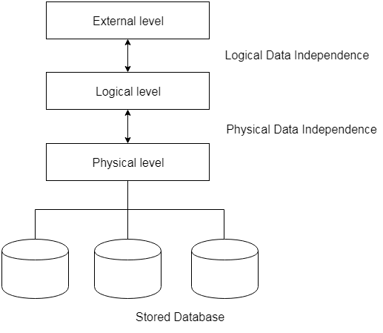
- If we do any changes in the conceptual view of the data, then the user view of the data would not be affected.
- Logical data independence occurs at the user interface level.

2. Physical Data Independence
- Physical data independence can be defined as the capacity to change the internal schema without having to change the conceptual schema.
- If we do any changes in the storage size of the database system server, then the Conceptual structure of the database will not be affected.
- Physical data independence is used to separate conceptual levels from the internal levels.
- Physical data independence occurs at the logical interface level.

DBMS Architecture
- The DBMS design depends upon its architecture. The basic client/server architecture is used to deal with a large number of PCs, web servers, database servers and other components that are connected with networks.
- The client/server architecture consists of many PCs and a workstation which are connected via the network.
- DBMS architecture depends upon how users are connected to the database to get their request done.

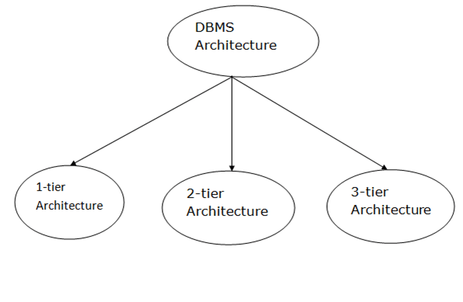
Types of DBMS Architecture :
Database architecture can be seen as a single tier or multi-tier. But logically, database architecture is of two types like: 2-tier architecture and 3-tier architecture.

1-Tier Architecture
- In this architecture, the database is directly available to the user. It means the user can directly sit on the DBMS and uses it.
- Any changes done here will directly be done on the database itself. It doesn't provide a handy tool for end users.
- The 1-Tier architecture is used for development of the local application, where programmers can directly communicate with the database for the quick response.

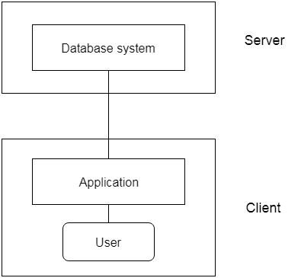
2-Tier Architecture
- The 2-Tier architecture is same as basic client-server. In the two-tier architecture, applications on the client end can directly communicate with the database at the server side. For this interaction, API's like: ODBC, JDBC are used.
- The user interfaces and application programs are run on the client-side.
- The server side is responsible to provide the functionalities like: query processing and transaction management.
- To communicate with the DBMS, client-side application establishes a connection with the server side.

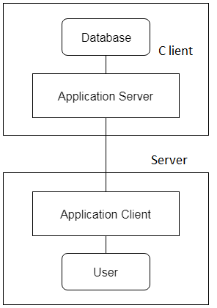
3-Tier Architecture
- The 3-Tier architecture contains another layer between the client and server. In this architecture, client can't directly communicate with the server.
- The application on the client-end interacts with an application server which further communicates with the database system.
- End user has no idea about the existence of the database beyond the application server. The database also has no idea about any other user beyond the application.
- The 3-Tier architecture is used in case of large web application.

E.F. Codd’s 12 Rules for RDBMS
Rule 0 − Foundation rule
Any relational database management system that is propounded to be RDBMS or advocated to be a RDBMS should be able to manage the stored data in its entirety through its relational capabilities.
Rule 1 − Rule of Information
Relational Databases should store the data in the form of relations. Tables are relations in Relational Database Management Systems. Be it any user defined data or meta-data, it is important to store the value as an entity in the table cells.

Rule 2 − Rule of Guaranteed Access:
The use of pointers to access data logically is strictly forbidden. Every data entity which is atomic in nature should be accessed logically by using a right combination of the name of table, primary key represented by a specific row value and column name represented by attribute value.
Rule 3 − Rule of Systematic Null Value Support :
Null values are completely supported in relational databases. They should be uniformly considered as ‘missing information’. Null values are independent of any data type. They should not be mistaken for blanks or zeroes or empty strings. Null values can also be interpreted as ‘inapplicable data’ or ‘unknown information.’
Rule 4 − Rule of Active and online relational Catalog :
In the Database Management Systems lexicon, ‘metadata’ is the data about the database or the data about the data. The active online catalog that stores the metadata is called ‘Data dictionary’. The so called data dictionary is accessible only by authored users who have the required privileges and the query languages used for accessing the database should be used for accessing the data of data dictionary.
Rule 5 − Rule of Comprehensive Data Sub-language :
A single robust language should be able to define integrity constraints, views, data manipulations, transactions and authorizations. If the database allows access to the aforementioned ones, it is violating this rule.
Rule 6 − Rule of Updating Views :
Views should reflect the updates of their respective base tables and vice versa. A view is a logical table which shows restricted data. Views generally make the data readable but not modifiable. Views help in data abstraction.
Rule 7 − Rule of Set level insertion, update and deletion :
A single operation should be sufficient to retrieve, insert, update and delete the data.
Rule 8 − Rule of Physical Data Independence :
Batch and end user operations are logically separated from physical storage and respective access methods.
Rule 9 − Rule of Logical Data Independence :
Batch and end users can change the database schema without having to recreate it or recreate the applications built upon it.
Rule 10 − Rule of Integrity Independence :
Integrity constraints should be available and stored as metadata in data dictionary and not in the application programs.
Rule 11 − Rule of Distribution Independence :
The Data Manipulation Language of the relational system should not be concerned about the physical data storage and no alterations should be required if the physical data is centralized or distributed.
Rule 12 − Rule of Non Subversion :
Any row should obey the security and integrity constraints imposed. No special privileges are applicable.
Database Design : Database design is the organization of data according to a database model. The designer determines what data must be stored and how the data elements interrelate. With this information, they can begin to fit the data to the database model.
The database design process can be divided into six steps
- Requirements Analysis
- Conceptual Database Design
- Logical Database Design
- Schema Refinement
- Physical Database Design
- Application and Security Design
1. Requirements Analysis : This is the first step in designing a database application is to understand what data to be stored in the database, what applications must be built on top of it , and what operations are most frequent and subject to performance requirements.
2. Conceptual Database Design: The goal of this step is to create simple description of the data that closely matches how user and developers think of the data. This step is carried out using the ER model.
3. Logical Database Design : In this step, we must choose a DBMS to implement our database design, and convert the conceptual database design into a database schema in the data model of the chosen DBMS. The result is conceptual schema called as logical schema.
- Schema Refinement : This step is used to analyze the collection of relations in our relational database schema to identify potential and to refine it.
- Physical Database Design : This step may simply involve building indexes on some tables and clustering some tables or it may involve a substantial redesign of parts of the database schema obtained from the earlier design steps in order to meet desired performance.
- Application & Security Design : In this step identify the entities and processes involved in the application and describe the role of each entity in every process that is reflected in some applications. For each role, we must identify the parts of database that must be accessible or not accessible. We must ensure that these access rules are enforced.
Entity – Relationship model is the high-level data model. It stands for the Entity-relationship model and is used to represent a logical view of the system from a data perspective. Creating an ER Model in DBMS is considered a best practice before implementing your database because it makes it easier for the developers to understand the database system just by looking at the ER model. It develops a conceptual design for a database that provides a very simple and straightforward view of the data. ER model makes use of ER diagrams, which are the diagrams sketched to design a database. ER diagrams are built on three basic concepts: entities, attributes, and relationships between them. An ER diagram in DBMS defines entities, associated attributes, 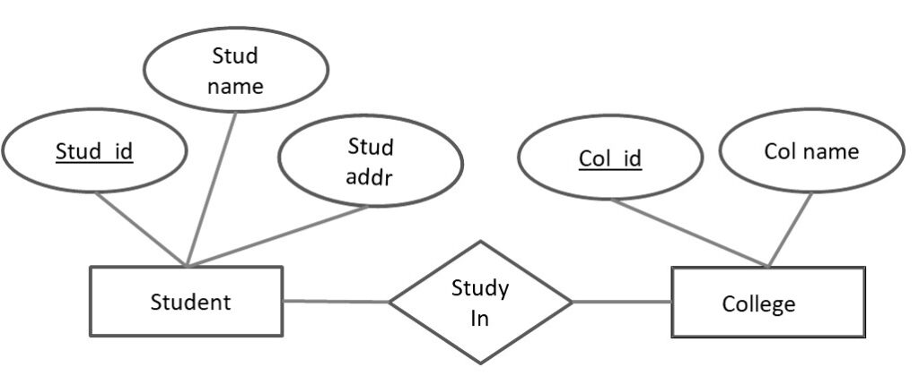
and relationships between entities. This helps visualize the logical structure of the database. The ER diagram was proposed by Peter Chen in 1971 as a visual tool to represent the ER model. He wanted to use the ER model as a conceptual modeling approach for DBMS. Let's understand this with the help of a simple example. Suppose you need to design a database for a school. In this database, a student is an entity with attributes such as an address, name, id, age, grades, etc.
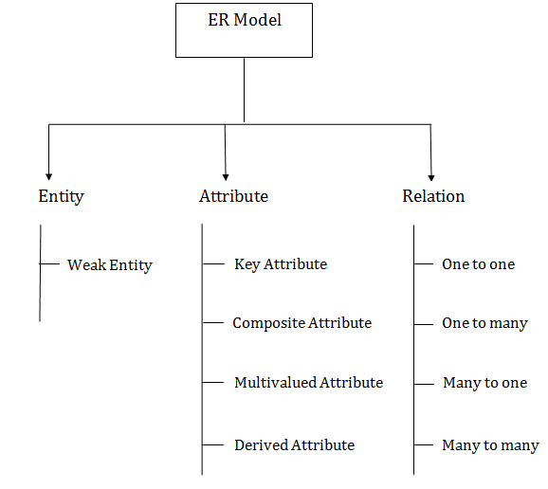
The address can be another entity with attributes like city, street name, pin code, etc and there will be a relationship between them.

Component of ER Diagram:

ER diagram consists of three basic concepts :

Entities

Attributes

Relationships

Entity :
An entity is an object in the real world that is distinguishable from other objects. Examples such as Employee, Department, Students etc.. Each entity consists of several characteristics or attributes that describe that entity. For example, if a Student is an entity, its attributes or characteristics are age, name, programme, brach, DOB, address and so on.
STUDENT

Entity set: is a group of entities of similar kinds. It can contain entities with attributes that share similar values. It's collectively a group of entities of a similar type. For example, a car entity set, a bank account entity set, and so on.

Entities are of two types:
- Strong Entity – A strong entity is an entity type that has a key attribute. It doesn't depend on other entities in the schema. A strong entity always has a primary key, and it is represented by a single rectangle in the ER diagram.
Example – roll_number identifies each student of the organization uniquely and hence,
we can say that the student is a strong entity type.
- Weak Entity – Weak entity type doesn’t have a key attribute and so we cannot uniquely identify them by their attributes alone. Therefore, a foreign key must be used in combination with its attributes to create a primary key. They are called Weak entity types because they can’t be identified on their own. A weak entity is represented by a double-outlined rectangle in ER diagrams. An entity that depends on another entity called a weak entity.
Example for weak entity:
  - In the ER diagram, we have two entities Employee and Dependents.
  - Employee is a strong entity because it has a primary key attribute called Employee number (Employee_No) which is capable of uniquely identifying all the employee.
  - Unlike Employee, Dependents is weak entity because it does not have any primary key .
  - D_Name along with the Employee_No can uniquely identify the records of Dependents. So here the D_Name (Depends Name) is partial key.
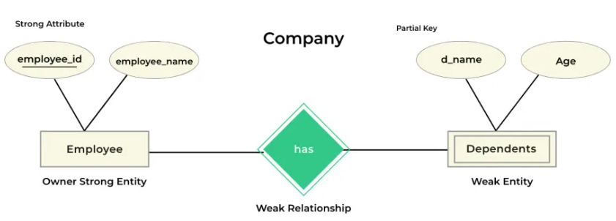The relationship between a weak entity type and a strong entity type is shown with a double-outlined diamond instead of a single-outlined diamond. This representation can be seen in the image given below.

Strong entity | Weak entity
Strong entity always has a primary key. | It will not have a primary key but it has partial key.
It is not dependent on any other entity. | Weak entity is dependent on the strong entity.
Represented by a single rectangle. | Represented by double rectangle.
Relationship between two strong entities is represented by a single diamond. | Relationship between a strong entity and the weak entity is represented by double Diamond.
A strong entity may or may not have total participation. | It has always total participation.

Attribute
Attributes are the characteristics or properties which define the entity type. In ER diagram, the attribute is represented by an oval.
For example, here id, Name, Age, and Mobile_No are the attributes that define the entity type Student.

There are seven types of attributes:
1. Simple attribute: Attributes that cannot be further decomposed into sub-attributes are called simple attributes. It's an atomic value and is also known as the key attribute. The simple attributes are represented by an oval shape in ER diagrams with the attribute name underlined.
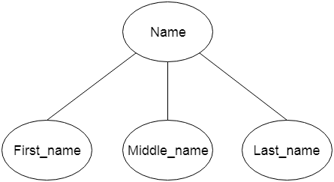
For example, the roll number of a student, or the student's contact number are examples of simple attributes. As you can see from the above image, the attributes id is represented in the shape of an ellipse along with having the attribute name underlined.
- Composite attribute: An attribute that can be decomposed into many other attributes is known as composite attribute. The composite attribute is represented by an ellipse, and those ellipses are connected with an ellipse.

Single-Valued Attributes : Single valued attributes are those attributes that consist of a single value for each entity instance and can't store more than one value. The value of these single-valued attributes always remains the same, just like the name of a student.

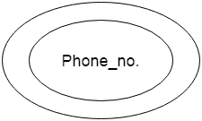
Multivalued attribute : An attribute can have more than one value. These attributes are known as a multivalued attribute. The double oval is used to represent multivalued attribute.
For example, a student can have more than one phone number.
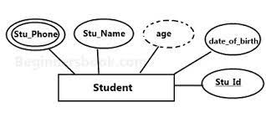
- Derived Attributes: are those attributes whose values can be derived from the values of other attributes. They are always dependent upon other attributes for their value.
For example, As we were discussing above, DOB is a single-valued attribute and remains constant for an entity instance. From DOB, we can derive the Age attribute, which changes every year, and can easily calculate the age of a person from his/her date of birth value. Hence, the Age attribute here is derived attribute from the DOB single-valued attribute.

Key Attributes : Key attributes are special types of attributes that act as the primary key for an entity and they can uniquely identify an entity from an entity set. The values that key attributes store must be unique and non-repeating.

Complex Attributes : Complex attributes are rarely used in DBMS. They are formed by the combination of multi-valued and composite attributes. These attributes always have many sub-sections in their values.

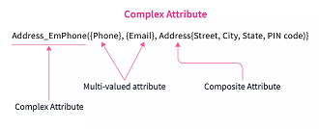
For example, Address_EmPhone (which represents Address, Email, and Phone number altogether) is a complex attribute. Email and Phone number are multi-valued attributes while Address is a composite attribute which is further subdivided as House number, Street, City & State. This combination of multi-valued and composite attributes altogether forms a complex attribute.

Relationship: The concept of relationship in DBMS is used to describe the association between different entities. This is denoted by the diamond. For example, the teacher entity type is related to the student entity type and their relation is represented by the diamond shape.
There are four types of relationships:

- One-to-One Relationships: When only one instance of an entity is associated with the relationship to one instance of another entity, then it is known as one to one relationship. For example, let us assume that a person has one passport and a passport can be owned by one person. Therefore the relation is
one-to-one.
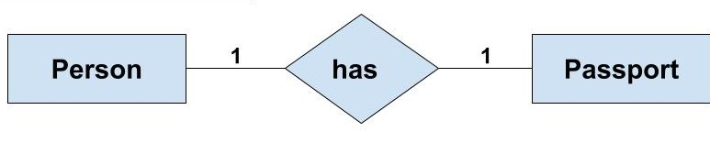
- One-to-Many Relationships: If only one instance of the entity on the left side of the relationship is linked to multiple instances of the entity on the right side, then this is considered a given one-to-many relationship. For example, a customer can place many orders. But any order is placed by only one customer.
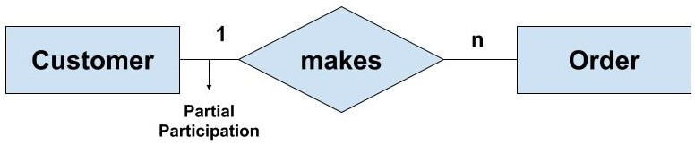
- Many-to-One Relationships: If only one instance of the entity on the left side of the relationship is linked to multiple instances of the entity on the right side, then this is considered a given one-to-many relationship. For example, a Student enrolls for only one course, but a course can have many students.
- Many to Many Relationships: If multiple instances of the entity on the left are linked by relationships to multiple instances of the entity on the right, this is considered a many-to-one-relationship means relationship. For example, a customer can buy many products and a product is purchased by many customers.
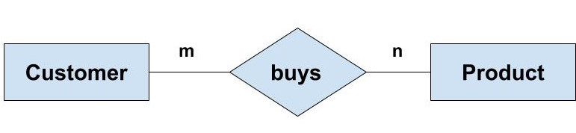

Relationship Sets :

A relationship set is a set of relationships of same type. A relationship set may be a unary relationship set or binary relationship set or ternary relationship set or n-ary relationship set.

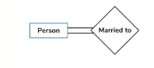
Unary Relationship :

Unary relationship set is a relationship set where only one entity set participates in a relationship set. Example-. One person is married to only one person. The degree of relationship is 1.

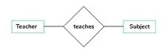
Binary Relationship :

A binary relationship is relationship set where two entities participate in a relationship set. Example – A teacher teaches subjects. Here Teacher and Subject are two entities. The degree of relationship is 2.
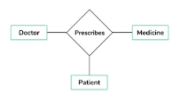

Ternary Relationship :

A Ternary relations is a relationship set where three entities participate in a relationship. Example – Doctor prescribes Medicines and Patient use these medicines prescribed by Doctor. The degree of relationship is 3.

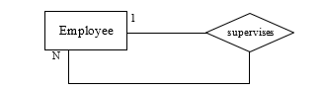
Recursive Relationship :

When there is a relationship between two entities of the same type, it is known as a recursive relationship. This means that the relationship is between different instances of the same entity type. An employee can supervise multiple employees. Hence, this is a recursive relationship of entity employee with itself.

Relationship Type and Relationship Set
A Relationship Type represents the association between entity types. For example, ‘Enrolled in’ is a relationship type that exists between entity type Student and Course. In ER diagram, the relationship type is represented by a diamond and connecting the entities with lines.
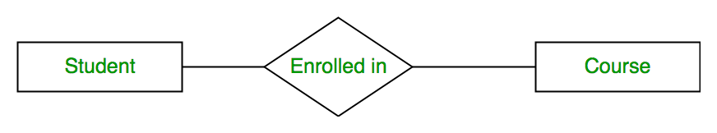
Entity-Relationship Set
A set of relationships of the same type is known as a relationship set. The following relationship set depicts S1 as enrolled in C2, S2 as enrolled in C1, and S3 as registered in C3.
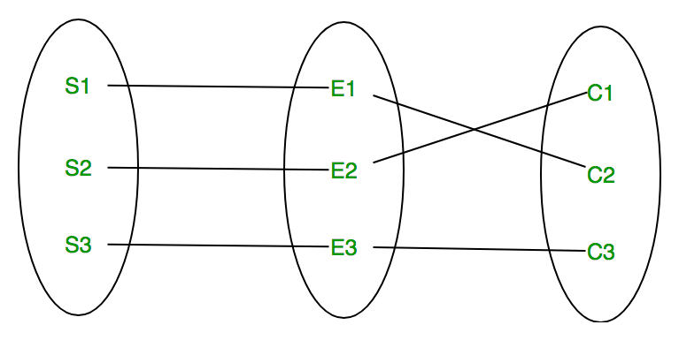
Relationship Set

Degree of a Relationship Set
The number of different entity sets participating in a relationship set is called the degree of a relationship set.
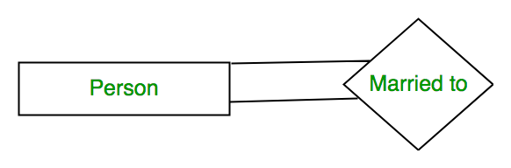
1. Unary Relationship: When there is only ONE entity set participating in a relation, the relationship is called a unary relationship. For example, one person is married to only one person.

Unary Relationship
2. Binary Relationship: When there are TWO entities set participating in a relationship, the relationship is called a binary relationship. For example, a Student is enrolled in a Course.
Binary Relationship
3. n-ary Relationship: When there are n entities set participating in a relation, the relationship is called an n-ary relationship.

Cardinality : The number of times an entity of an entity set participates in a relationship set is known as cardinality. Cardinality can be of different types:

1. One-to-One: When each entity in each entity set can take part only once in the relationship, the cardinality is one-to-one. Let us assume that a male can marry one female and a female can marry one male. So the relationship will be one-to-one.
the total number of tables that can be used in this is 2.
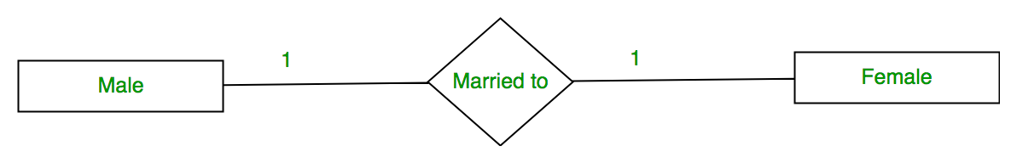
One-to-One Cardinality

2. One-to-Many: In one-to-many mapping as well where each entity can be related to more than one relationship and the total number of tables that can be used in this is 2.
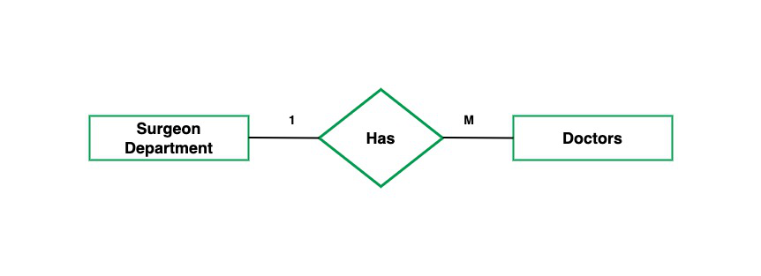
One to Many
3. Many-to-One: When entities in one entity set can take part only once in the relationship set and entities in other entity sets can take part more than once in the relationship set, cardinality is many to one. Let us assume that a student can take only one course but one course can be taken by many students. So the cardinality will be n to 1. It means that for one course there can be n students but for one student, there will be only one course.
The total number of tables that can be used in this is 3.
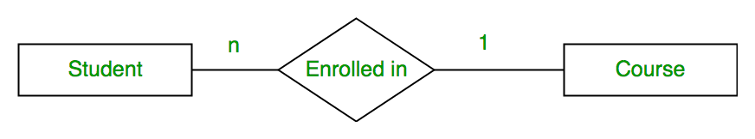
Many-to-One Relationship
4. Many-to-Many: When entities in all entity sets can take part more than once in the relationship cardinality is many to many. Let us assume that a student can take more than one course and one course can be taken by many students. So the relationship will be many to many.
the total number of tables that can be used in this is 3.
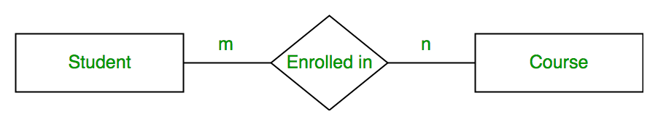
Many-to-Many

Participation Constraint
Participation Constraint is applied to the entity participating in the relationship set.

1. Total Participation – Each entity in the entity set must participate in the relationship. If each student must enroll in a course, the participation of students will be total. Total participation is shown by a double line in the ER diagram.

2. Partial Participation – The entity in the entity set may or may NOT participate in the relationship. If some courses are not enrolled by any of the students, the participation in the course will be partial.
The diagram depicts the ‘Enrolled in’ relationship set with Student Entity set having total participation and Course Entity set having partial participation.
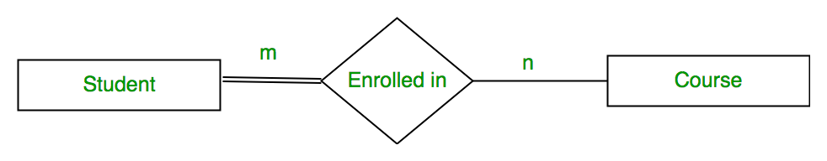
Total Participation and Partial Participation
Using Set, it can be represented as,
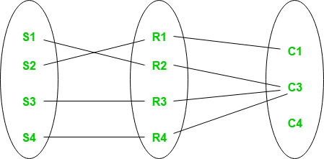
Set representation of Total Participation and Partial Participation
Every student in the Student Entity set participates in a relationship but there exists a course C4 that is not taking part in the relationship.

